Skill-based learning websites

Definition:
# Source: AI Source: Provided by: [Data Path: Persons Table -> ID Column: 1, Name_En Column: Motasem Essam] -> From: [Chatgpt (GPT‑5 Mini)] on [2/12/2026]
Skill-based learning websites are online platforms designed to help users learn specific skills or practical abilities, often focused on professional or personal development.

Simple Definition
# Source: AI Source: Provided by: [Data Path: Persons Table -> ID Column: 1, Name_En Column: Motasem Essam] -> From: [Chatgpt (GPT‑5 Mini)] on [2/12/2026]
Skill-based learning website = a website where you learn a particular skill, like coding, design, cooking, or photography, usually through tutorials, exercises, and projects.

What Skill-Based Learning Websites Usually Include
# Source: AI Source: Provided by: [Data Path: Persons Table -> ID Column: 1, Name_En Column: Motasem Essam] -> From: [Chatgpt (GPT‑5 Mini)] on [2/12/2026]
- Courses or Tutorials – step-by-step guides for a specific skill
- Projects / Assignments – practical exercises to apply knowledge
- Quizzes & Assessments – test understanding and mastery
- Progress Tracking – monitor learning progress
- Certificates / Badges – proof of skill acquisition
- Community / Forums – interact with instructors or peers

Examples of Skill-Based Learning Websites
# Source: AI Source: Provided by: [Data Path: Persons Table -> ID Column: 1, Name_En Column: Motasem Essam] -> From: [Chatgpt (GPT‑5 Mini)] on [2/12/2026]
- Codeacademy – coding and programming skills
- Udemy – design, marketing, photography, and many other skills
- Skillshare – creative and professional skills courses
- LinkedIn Learning – professional development and business skills

Purpose of Skill-Based Learning Websites
# Source: AI Source: Provided by: [Data Path: Persons Table -> ID Column: 1, Name_En Column: Motasem Essam] -> From: [Chatgpt (GPT‑5 Mini)] on [2/12/2026]
- Teach practical skills for career or personal growth
- Offer flexible learning online
- Allow hands-on practice through projects
- Provide recognition for skills learned (certificates)
- Help learners improve employability or hobbies

Difference from Other Educational Websites
# Source: AI Source: Provided by: [Data Path: Persons Table -> ID Column: 1, Name_En Column: Motasem Essam] -> From: [Chatgpt (GPT‑5 Mini)] on [2/12/2026]
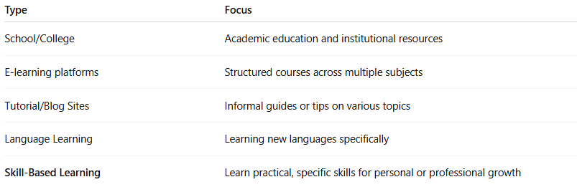
Type | Focus
School/College | Academic education and institutional resources
E-learning platforms | Structured courses across multiple subjects
Tutorial/Blog Sites | Informal guides or tips on various topics
Language Learning | Learning new languages specifically
Skill-Based Learning | Learn practical, specific skills for personal or professional growth

